**EXPERIMENT :11**

Demonstrate virtualization by Installing Type -2 Hypervisor in your device, create and configure VM image with a Host Operating system (Either Windows/Linux)

**AIM:**

**PROCEDURE:**

**STEP 1:**Dowload VMware workstation and installed as type 2 hypervisor.

**STEP2:**Dowload ubuntu or tiny OS as iso image file.

**STEP 3:** In VMware workstation->create new VM.

**STEP 4:** Do the basic configuration settings.

**STEP 5:** Created tiny OS virtual machine.

**STEP 6:** Launch the VM.

IMPLEMENTATION:

**STEP 1:DOWLOAD VMWARE WORKSTATION AND INSTALLED AS TYPE 2 HYPERVISOR**

**Step 1:**

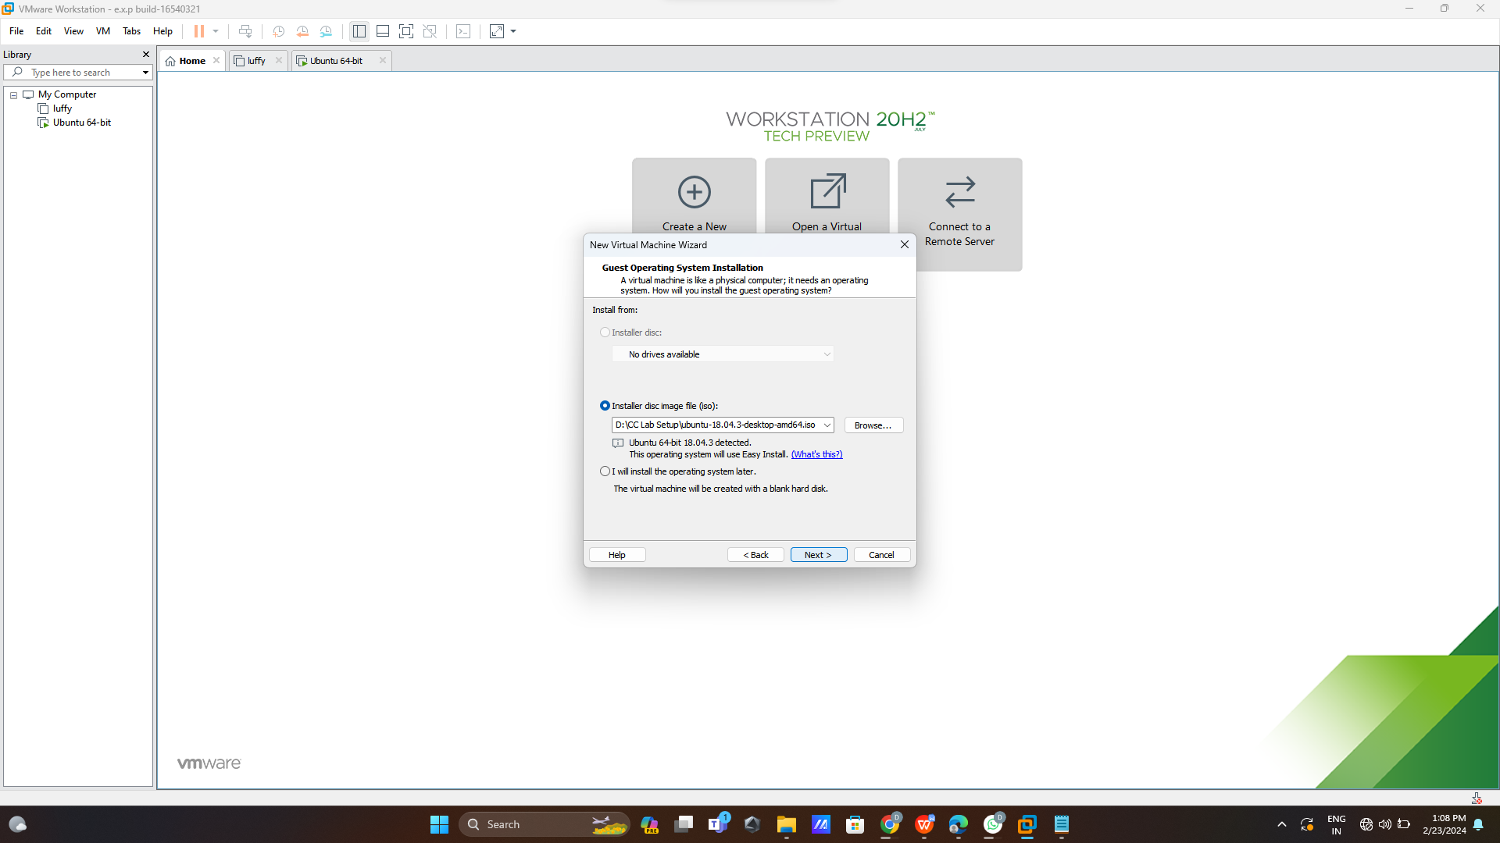

**Step 2:create id and password**

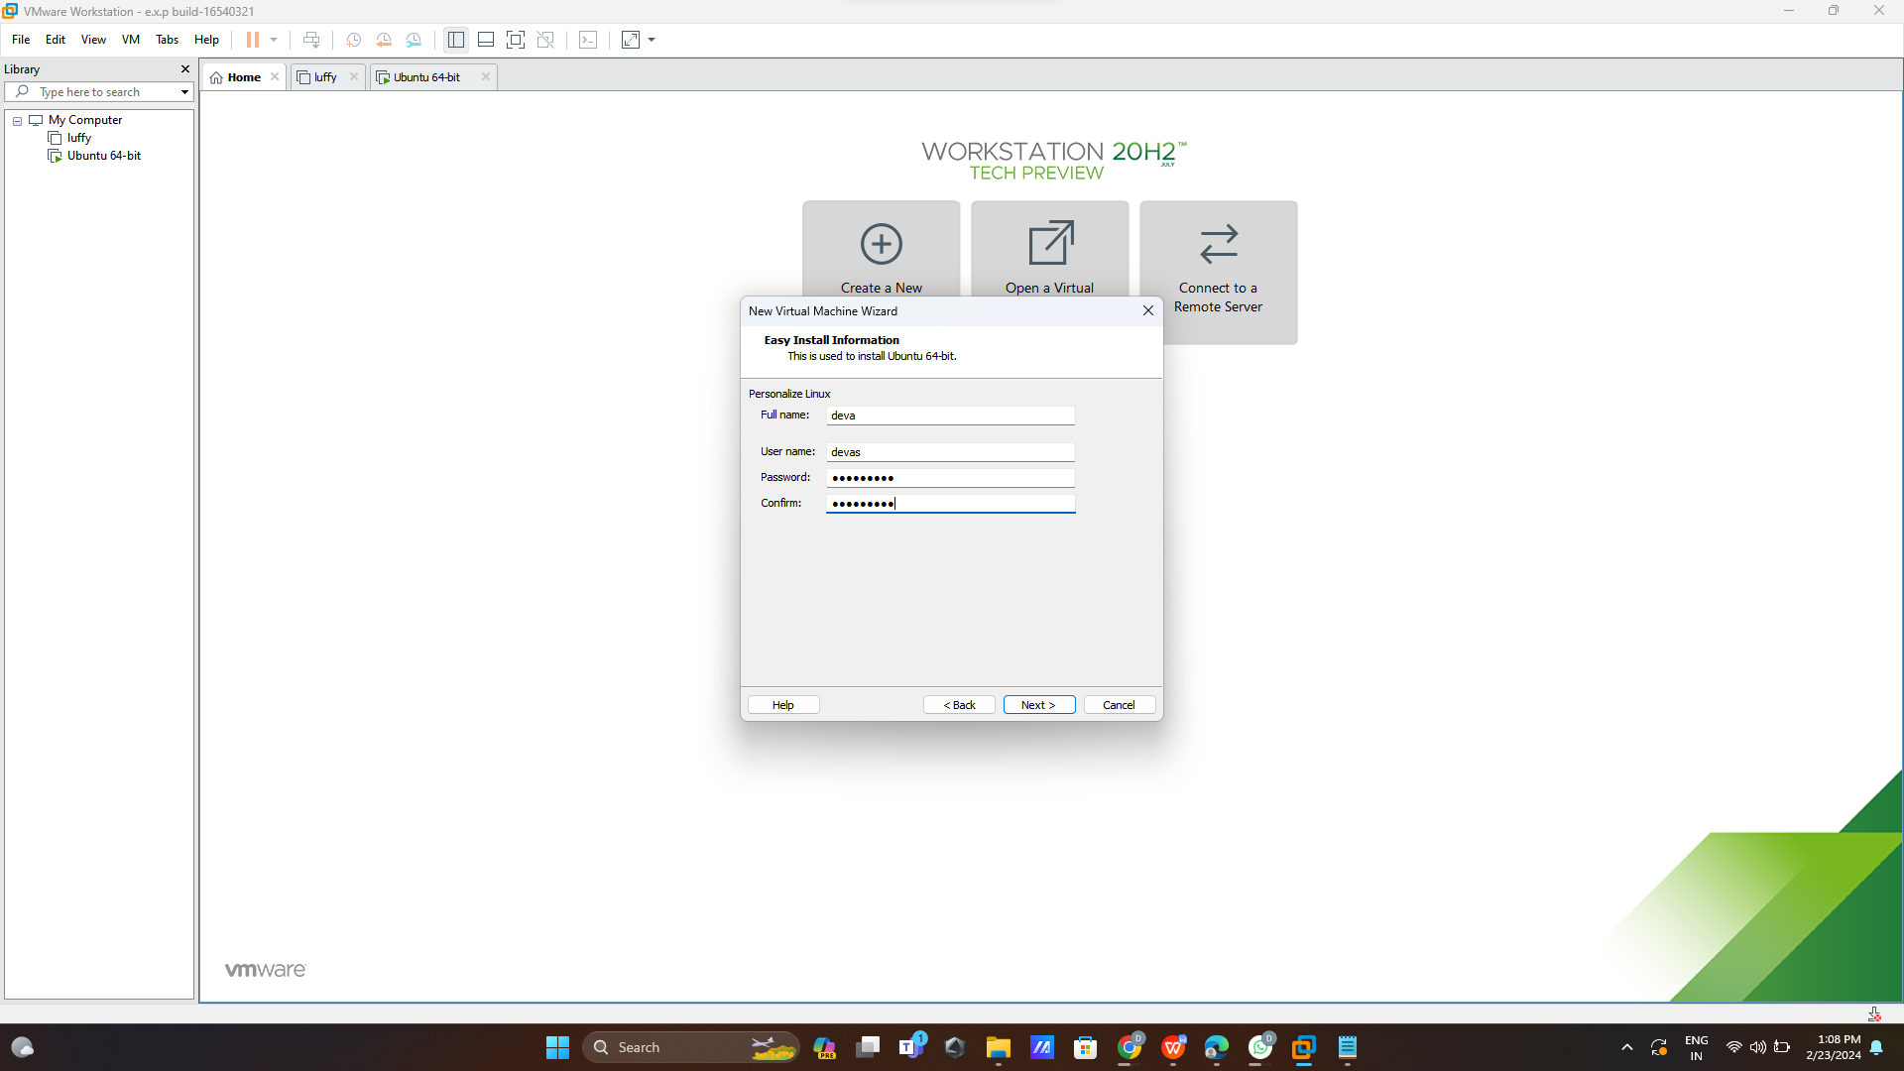

**Step 3:**

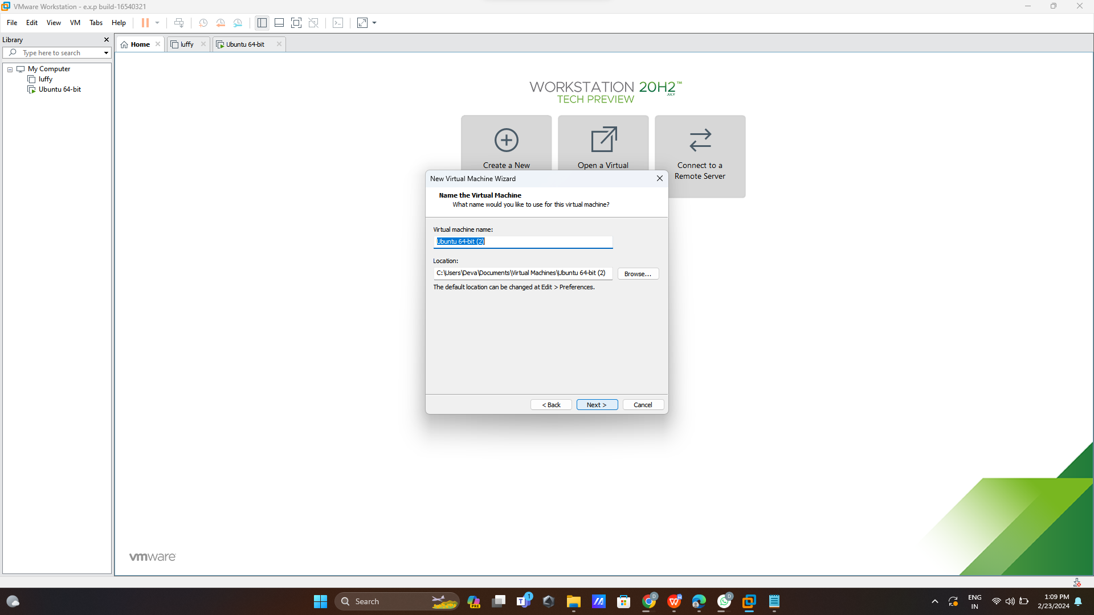

**Step 4:add size 30GB**

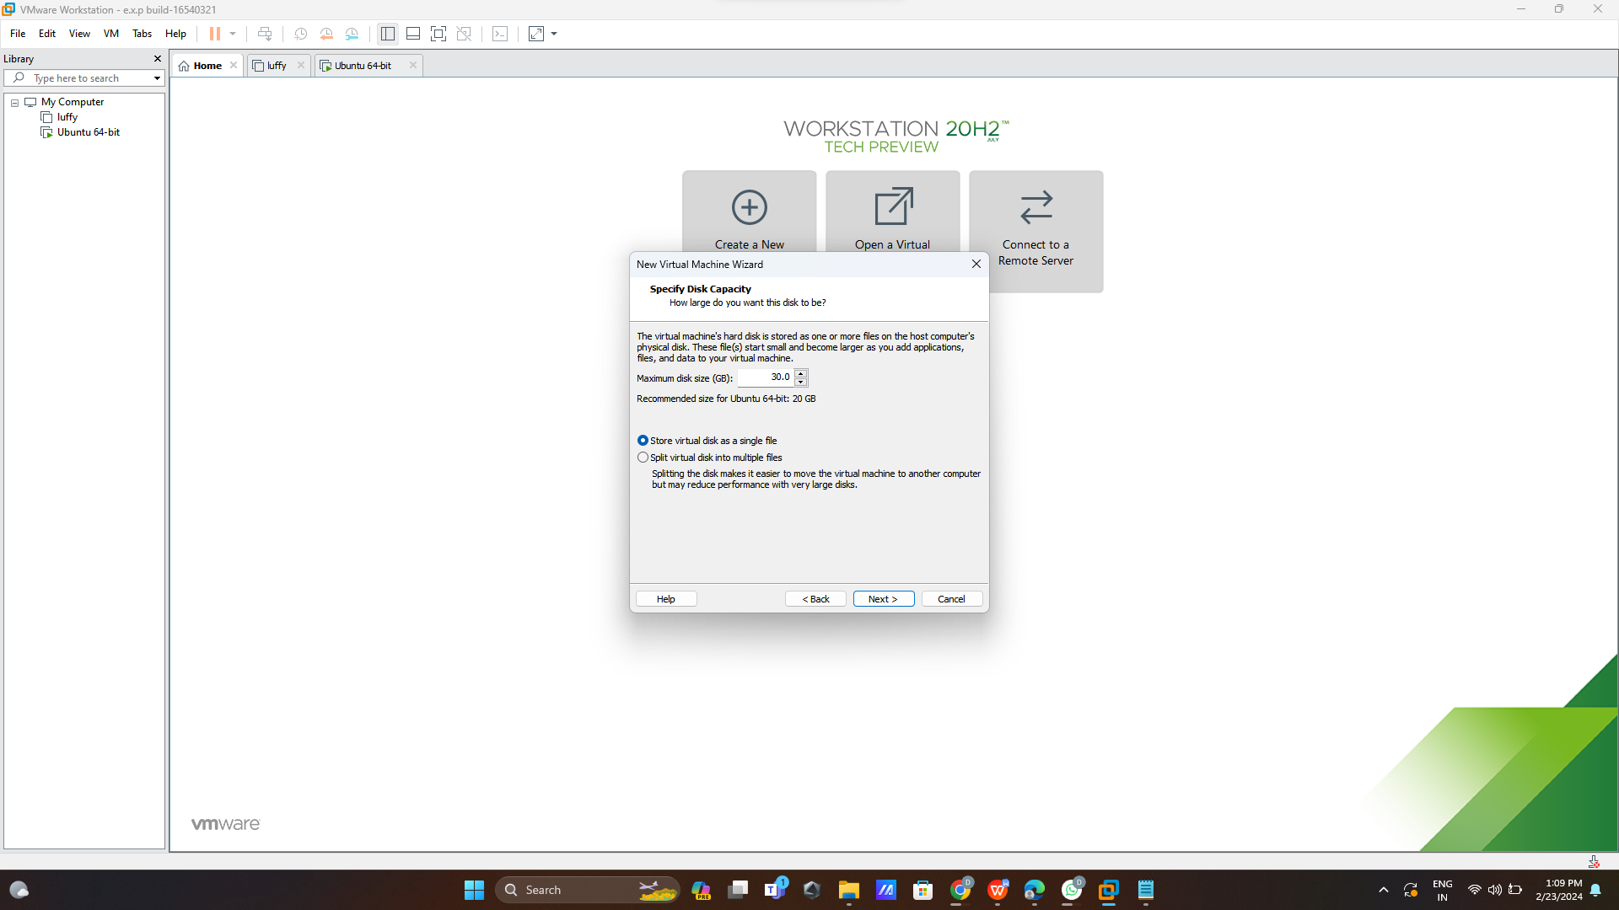

**Step 5:**

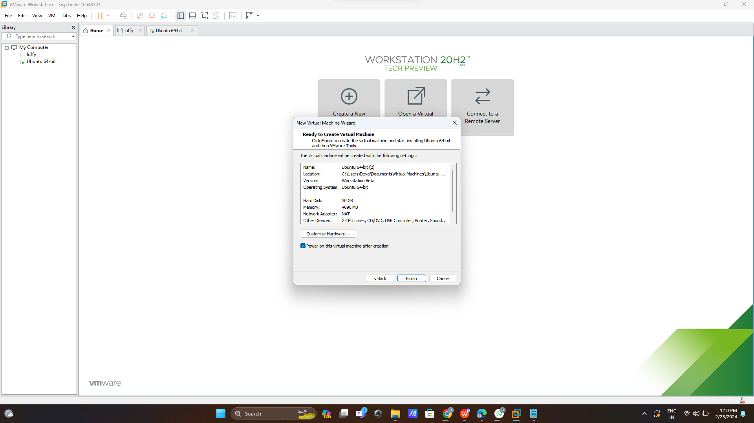

**Step 6:run**

